Vietnamese Community – Focus Group Results
A focus group with Vietnamese residents was conducted with the assistance of Helping Link on May 30, 2013. This was part of the Information Technology Access and Adoption in Seattle: Progress towards digital opportunity and equity study conducted by the City of Seattle. Nineteen individuals attended the focus group, in addition to four bilingual note-takers/ table facilitators, and a bilingual facilitator. Nineteen participants completed at least part of a brief written survey. Participants engaged in planned focus group activities – including a dynamic method that relies on mutual interviewing among the community members – and did so with evident interest and engagement.
Table 1. Group demographic description
 | Percentage
% women | 71%
Education
Less than high school | 38%
HS grad/GED | 50%
Some college/AA/AS | 6%
BA/BS | 6%
Post grad work/degree | 0%
Age
18-25 | 13%
26-35 | 7%
36-50 | 27%
51-64 | 27%
65 or older | 27%
Employment
Employed | 47%
Retired | 27%
Homemaker | 0%
Student | 7%
Disabled | 7%
Unemployed | 13%
Income
<$20,000 | 73%
$20K-$30K | 20%
$30K-$40K | 7%
$40K-$50K | 0%
$50K-$75K | 0%
$75K-$100K | 0%
$100K+ | 0%

Table 1 summarizes the demographic distribution of the participants. Most of the participants are women with no more than a high school diploma. A wide age range attended, slightly skewed toward those over 35. Most participants were employed or retired, but with low annual household incomes (less than $20,000 for about three-fourths; only seven percent reported incomes over $30,000).
Half of the participants live with another adult and half live with children younger than 18.
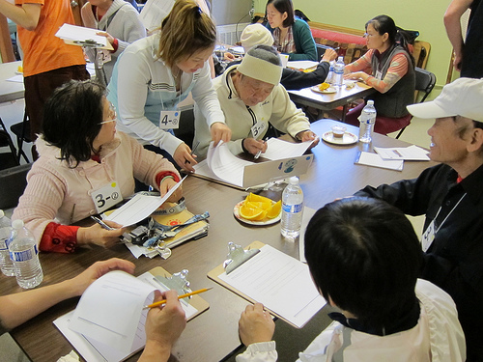
Summary
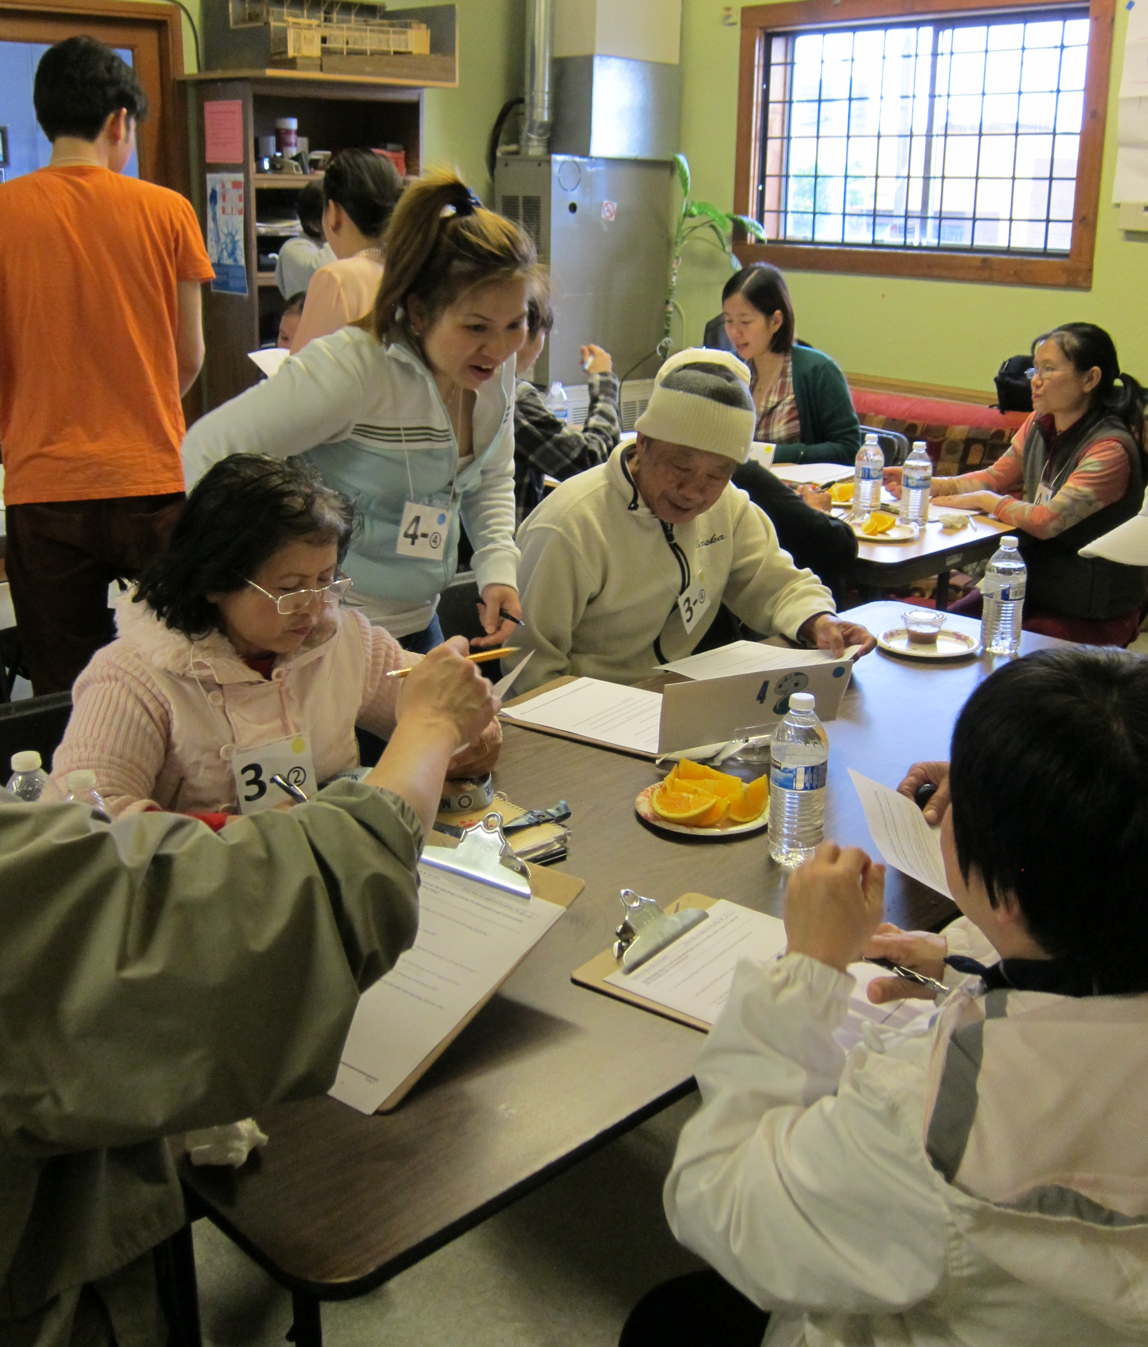
These Vietnamese participants report having access to technology but many acknowledge that they do not know how to use it well. Nearly all have a cell phone - about half of these are smart phones, and very few use texting. Most have a laptop at home and about two-thirds have Internet. Although some are very comfortable with computers and the Internet, many report that they are not very skilled and mutual interviews reveal that many feel unable to navigate the Internet without help. Those without home Internet service either report that it is unaffordable, or that they don't know how to use it, or both. Despite reporting low skill levels, participants use the Internet to find information, especially health information and news, and to communicate with family and friends. Participants are interested in learning more, especially about how to perform practical tasks using computers and the Internet. Many mentioned that they prefer a classroom setting.
About half of the participants use a computer away from home - at the library or a community center, or a friend's or relative's home. However, they expressed some concerns about these locations - some find them inconvenient or the connection too slow, and some reported a concern with the safety of their information when they use public access computers.
Most of the participants in these groups were interested in trying the services provided by super high speed Internet, and listed "Internet" and "email" as the services that are most important to them. Currently, about two-thirds use email (less than half check their email daily and about one-third check it a few times a week). Very few say they use email attachments. About half use Facebook, and most of them check their Facebook account a few times a week. Though several concerns were expressed about getting information from the government via technology (e.g., information transmitted via the Internet may be insecure; Internet access is expensive; don't have Internet access at home; don't know how to use Facebook; potential language barriers), participants were willing to try Facebook for these purposes, but they more often preferred TV, email, and the City's website. When asked how they'd prefer to give opinions, participants’ suggestions included community events with a short meeting (in Vietnamese), email or online surveys, or paper surveys (in Vietnamese) that are mailed to them. “City services” was a frequently mentioned topic, and language barriers were often highlighted as a barrier. Just over half mentioned the telephone as the way they prefer to make contact with the City, and not quite as many preferred email, or writing a letter.
Technology Access and Use
Survey responses show that nearly all (89%) participants have a cell phone - and about half of them are smart phones. Very few (13%) use texting. Only about one-third reported having a landline.
Most (84%) have a computer at home (a laptop for 79% and a tablet for 21%) and 68% have Internet access at home, through only 42% said they have home Internet and the others indicated mobile access. Mutual interviewing produced similar results, with additional details from those conversations: those without home Internet access would like to have it or know about it but do not because it is unaffordable. Most of the participants with home access said it is good enough for their needs, with some complaints that their DSL is too slow or too expensive.
What is needed to use computers:
- When I know how to use the computer, I will use it every day.
In the survey and mutual interviewing about two-thirds say they use the Internet. Few (13%) use attachments to their emails.
This group selected an average of four uses for computers and the Internet, illustrated in Figure 1. Participants use the Internet primarily for getting information, especially about health issues. They also use the Internet to find community information, to visit the library online, and to watch TV.
Interviewers asked what their interviewees liked best (or would like) about using computers and the Internet. Nearly all (86%) mentioned being able to read the news and 71% mentioned communication - either email or chat - with friends and family. A few mentioned online shopping or entertainment, playing games, and checking bus routes.
Like about using computers and the Internet
- To have the ideas about the world; reading news every day.
- Talk with my friends and family. Reading news about Seattle.

Figure 2 shows where participants use computers according to their responses to the survey. Most (80%) use computers at home, about a third each at the library or a friend's or relative's house. Note that, taken together, half of the respondents use computers at the library, a friend’s or relative’s, a community technology center or a café or restaurant, even if they have access at home. Mutual interviewing revealed that about one-third of the interviewees use a computer away from home and that whether or not these alternatives are convenient, interviewees prefer to use their home computer. Interviewees expressed concerns about the speed of connection away from home, and about the safety of their information using public access computers.
Of those who have home Internet access, 65% get it through the cable company (including the 18% with cable and a data plan for their smart phone), and about one-third get it through DSL.
When asked about their satisfaction with their home Internet service, nearly all (92%) were satisfied with the Internet's reliability, about two-thirds (69%) were satisfied with the speed and about 58% with the cost. Only half were satisfied with the customer service. Notably, though, when asked what one thing would most improve their cable service, 82% said “price.” Not quite as many (71%) said “speed,” and 57% each chose “customer service” and “reliability.”
When asked how much they would pay for service or for faster service, one third said "Nothing." Seventeen percent said they would pay between $5 and $10 per month and a quarter (25%) selected between $ and $20 per month. Seventeen percent would pay between $40 and $50 per month.
When asked how skilled they are with computers, only 12% rated themselves above the scale’s midpoint and 82% rated themselves below it, with 38% selecting “none” or “not very” skilled and 44% selecting “Know what I need to know.” Interviewers reported that although most of the participants use the Internet, only a few are able to navigate it themselves.
Very few people responded to the question asking why they or others in their community don’t use computers or the Internet. Of those who responded, 60% thought it is because people don’t know enough about computers or the Internet to use them; 40% thought it’s because monthly Internet service is too expensive, and 20% each thought it might be related to the cost of a computer, and to computer-related security concerns.
High Speed Internet
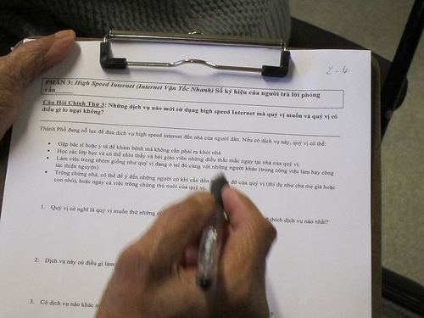
These sessions included the opportunity for the City to talk about the potential and possible availability of super high speed Internet in Seattle, and some of the participants discussed the pros and cons in detail.
Most people (89%) were interested in trying super high speed Internet, with about half saying they would like to try all the applications listed (visit the doctor or nurse without leaving home, take classes and be able to see and ask the teacher questions from your own home, work in groups like you were right there with each other, or keep an eye on things at home while you're away) and others specifying that they are most interested in email and the Internet or email and the phone. However, almost half (42%) expressed their concern that the service could be misused to send false information or scams. Participants volunteered comments about the importance of providing Vietnamese interfaces.

Cable TV and Video Content
Thirty-two percent of these participants subscribe to cable TV. Of those who responded, 83% selected “price” as the one thing that would most improve their cable service, followed by customer service (50%). Reliability was selected by 17%.
The shift away from cable toward other vehicles for watching TV content was evident in this focus group. Asked to rank a variety of choices for getting video content, respondents' top choice was to watch TV over the Internet using sources such as Netflix and Hulu (77%). When the second choice is added in, all respondents in this group watch TV over the Internet. The second choice is cable TV, the top choice of 54%, with another 13% ranking it second. Free TV was the top choice for 36% with another 31% giving it second or third rating. Satellite received top rank from only 7%, with another 23% ranking it second or third.
Seattle.gov and The Seattle Channel
Half of these participants have visited Seattle.gov and 92% have seen the Seattle Channel. Three-fourths of those have watched the Seattle Channel on cable and half have watched it on cable and over the Internet.
Seattle Channel and Seattle.gov
- If I get to learn how to browse websites, I would be able to visit the website and utilize the information.
- Want to know about everything evolving around my residence.
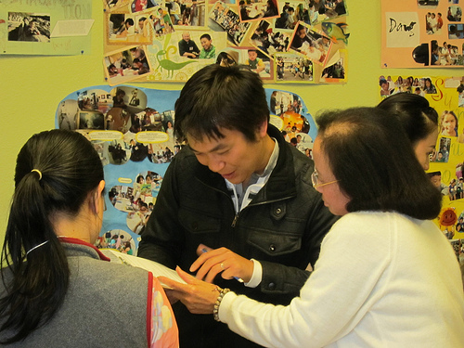
In mutual interviewing participants mentioned some topics that would make them more interested in communication from Seattle, including more information about their neighborhood, specifically problems that they would want to avoid; information about government policies and new regulations; news; and information about Vietnamese classes for children.
Social Media
In mutual interviewing, almost half of the participants said they use a social networking program. All of the current social media users mentioned Facebook, and a few also mentioned Twitter and LinkedIn. A few people (not included here as social media users) may not understand the basics of social media as they named "Google" and "Internet" as their social media programs. Of those that don't use it, 63% want to and say they don't use it just because they haven't learned how yet.
About one-third of survey respondents reports that they check email daily, and another quarter checks it a few times a week. About one-third don't use email at all or just didn't respond to the questions. One-third also say they check Facebook daily and another 11% check it a few times a week. About half don't use Facebook at all or didn't respond to the questions. None of these respondents reported using Twitter.
Comments about social media and government
- Using Facebook and Twitter is convenient, but I am afraid my confidential information will be leaked
- Facebook and Twitter is a fast way to get important news.
- I'm concerned about the language barrier
In mutual interviewing, participants said they like to use their social networking program for:
- communicating with other people (45%)
- keep up with news and local events (15%)
- to find information and services (36%)

In a variety of ways, participants expressed concern about the confidentiality of information received over the Internet, with specific focus on the possibility of getting false information from Facebook, as well as inappropriate photos, and too many ads.

Interviewers explored the possibility of using social media to communicate with government. Participants were largely positive about this idea, saying it would be a fast way to get important news. Those who are not social media users now said they would consider learning to use it to be able to communicate this way. Interviewees voiced three concerns: not knowing how to use social media and not having a teacher to help them; possible lack of security of personal information; and concern about the language barrier.
Communicating with Government
Interviewers report that nearly all interviewees would like to receive information from the government. The survey offered a series of checkboxes with different ways respondents might give opinions to the City. Figure 4 shows that about one third of the Vietnamese participants selected “community meeting” or community event with a short meeting for discussion of available resources from the City. About a third also selected "email or online survey." Interviewees said they'd also like to fill out a paper survey about city services mailed to their homes. Here again, a concern about language-appropriate communications was evident: interviewees urged the City to remember to provide interpretation services in meetings and to translate information and other material into Vietnamese.
Communication with the City
- Community meeting that has people speak in Vietnamese.
- Information and updated news to learn about new things and avoid bad things.
Interviewees had suggestions for how the City could more effectively provide information, and make it easier for residents to participate in improving their communities. Announcements via TV (31%), mail to their residence (23%), radio announcements (23%), community meetings with discussions (15%), or the Internet or email (15%) were all specified.
Some of the topics interviewees would like to see discussed include elders' need for homecare, and children's need for summer programs and tutoring in Math and English.
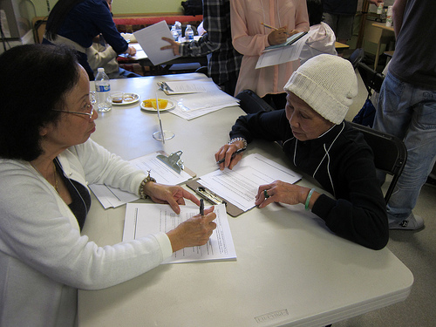
When asked how they prefer to make contact with the city, "telephone" was the most popular response, selected by 57%, followed by email (50%) and writing a letter (43%). Texting, Facebook and Twitter received fewer responses.

Asked how they would like to get information from the City, as illustrated in Figure 5, the most frequent choice for this group is via the TV news (58%) followed closely by email (50%), Seattle.gov (42%) and the Seattle Channel or the newspaper, each selected by one-third of the respondents.
Learning
In mutual interviewing, two-thirds of the participants discussed either specific types of classes they'd like to attend (most often computer and/or Internet classes, especially practical tasks, including how to access news sources) or types of learning environments (mostly classes, with a few requests for videos or one-on-one instructions). Interviewers reported that participants would also like to learn more about English.
 | See the full report with other focus groups and survey results at Seattle.gov/tech/indicators  City of Seattle Department of Information Technology  Community Technology Program

